DESIGN AND IMPLEMENTATION OF A SECURE CRYPTOGRAPHIC KEY MANAGEMENT SYSTEM FOR ELECTRONIC MEDICAL RECORDS IN LOCAL HEALTHCARE PROVIDERS

BY

MARCUS DENNIS TUSHI
BHU/22/04/09/0072

A PROJECT DOCUMENTATION SUBMITTED TO THE DEPARTMENT OF COMPUTER SCIENCE, FACULTY OF COMPUTING,
BINGHAM UNIVERSITY KARU, NASARAWA STATE NIGERIA

IN PARTIAL FULFILMEMT OF THE REQUIREMENTS OF THE AWARD OF BACHELOR OF SCIENCE (B.Sc.) DEGREE IN COMPUTER SCIENCE

JANUARY, 2026

DECLARATION
I Marcus Dennis Tushi with the Matriculation Number BHU/22/04/09/0072 hereby declare that this SIWES technical report was carried out by me and every other external work used in this report has been fully acknowledged.

…………………………. ……………………..
Marcus Dennis Tushi Date
BHU/22/04/09/0072

CERTIFICATION
This is to certify that this technical report was written by Marcus Dennis Tushi with Matric Number BHU/22/04/09/0072 for my Project proposal and submitted to the Department of Computer Science, Faculty of Computing, Bingham University, Karu, Nigeria, as part of the requirements for the award of Bachelor of Science (B.Sc.) in Computer Science.

____________________________ ____________________________
Mr. Barka T. Fori Date
Supervisor

____________________________ _____________________________
Dr. Adamu S. Usman Date
Head of Department

____________________________ _____________________________
Mr. Maikori Ezekiel Jenom Date
External Examiner

ACKNOWLEGEMENTS
I wish to express my sincere appreciation my supervisor Mr. Barka T. Fori for the guidance, inspiration and continuous support during the Six Months period of my IT.
I would like to thank the Dean of the Faculty of Computing and HOD of Department of Computer Science Dr. Adamu S. Usman. My profound gratitude goes to the Lecturers in the Department of Computer Science which include Dr. Yakubu Aliyu Ibrahim, Mrs. Oluwatoyin Adelakun Adeyemo, Mr. Maikori Ezekiel Jenome, Mr. Barka T. Fori, Mr. Emmanuel Dauda and Mr. Nathan Zoakah. A special thanks to all the Lecturers in Faculty of Computing which include: Head of Information Technology Dr. Anah Hassan Biljik, Head of Cyber Security Dr. Oluwasegun Ishaya Adelaye, Dr. Onu Egena, Dr. Victor E. Kulugh, Mr. Musa Yusuf, Mr. Ibrahim Lawal Mrs. Adelaiye A. Nancy. I also thank the Technologists in the Faculty which include: Mr. Joseph Oladele Aremu, Mr. Ngale Langthong and Mr. Sharack Akoh. I also appreciate the Faculty Officer, Mrs. Ajibade Blessing, the Departmental Secretary Mrs. Chioma Godsfavour and the Faculty Clerical Officer, Madam Mary Madaki. A big thank you to all the Teaching and Non-teaching Staff of the Faculty of Computing, Bingham University.
I would like to thank my loving parents Mr. and Mrs. Tushi for giving their support Financially, Morally, Emotionally and Spiritually. Also, I say thank you to my beloved siblings for being there for me always. I thank my fellow Students from the Department of Computer Science for their support and logical contributions in the various parts of my project.
Finally, I appreciate everyone whose name were not mention but has in one way or the other contributed to the success of this technical report. May Almighty God bless them all.

DEDICATION
This research work is dedicated to Almighty God the source of my knowledge and creator of the universe. I also dedicate this project to my loving parents Mr. and Mrs. Tushi and to my beloved siblings.
TABLE OF CONTENTS
DECLARATION 1
CERTIFICATION 2
ACKNOWLEGEMENTS 3
DEDICATION 5
CHAPTER ONE 1
INTRODUCTION 1
1.1 Background of Study 1
1.2 Statement of Problem 5
1.3 Aim and Objectives 8
1.4 Significance of the Study 9
1.5 Scope of Study 10
1.6 Organization of the Study 11
CHAPTER TWO 13
LITERATURE REVIEW 13
2.1 Introduction to the secure cryptographic key management system 13
2.2 Historical Context of the secure cryptographic key management system 14
2.3 Theoretical Framework 14
2.4 Key Concepts and Definitions 16
2.5 Empirical Review of Related Literature 17
2.5.1 Theme 1: Cryptographic Access Control in Healthcare 20
2.5.2 Theme 2: Multi-Tenant Database Isolation Strategies 21
2.5.3 Theme 3: Economics and Performance of Key Management Systems 22
2.6 Debates and Gaps in the Literature 23
CHAPTER THREE 24
SYSTEM DESIGN AND METHODOLOGY 24
3.1 Research Approach 24
3.2 Software Development Methodology 24
3.3 System Architecture and Workflow 25
3.4 System Modelling 28
3.5 Evaluation Plan and Cost-Benefit Analysis 32
Chapter Four 34
Implementation and Testing / Results and Discussion 34
4.1 Implementation 34
4.1.1 Hardware and Software Requirements 35
4.1.2 Core App (Core Medical Application API) 36
4.1.3 KMS (Key Management Server) 37
4.1.4 Audit Logging and Encrypted Audit Records 38
4.1.5 Logging Implementation Details 39
4.2 System Testing 40
4.2.1 Testing Approach and Methodology 40
4.2.2 Test Environment 41
4.2.3 Functional Testing (Endpoints) 41
4.2.4 Security Testing (Encrypted Log Integrity) 42
4.2.5 Reliability Testing (Handler Duplication and Cleanup) 42
4.3 Results Presentation 43
4.4 Discussion 45
Chapter Five 47
Summary, Conclusion and Recommendation 47
5.1 Summary 47
5.2 Conclusion 48
5.3 Recommendations 48
5.4 Areas for Further Research 50
REFERENCES 51

LIST OF FIGURES
Figure 3.1 Agile Development Life Cycle 26
Figure 3.2 Use Case Diagram Of Tenant System 26
Figure 3.3 Activity Diagram Of Tenant System 29
Figure 3.4 Sequence Diagram Of Tenant System 29

Figure 4. 1: Architecture overview of Core App, KMS, audit logging, and data flow. 35
Figure 4.2: Sequence for record creation: authentication → principal checks → record_created audit event. 37
Figure 4.3 : Sequence for DEK generation and encryption under tenant master key (RSA-OAEP). 38
Figure 4.4: Encrypted audit log binary framing: nonce length, nonce, ciphertext length, ciphertext. 39
Figure 4.5: Encrypted audit logs stored on disk and structured console audit output. 40
Figure 4.6: Sample decrypted JSON audit record showing structure and contextual metadata. 44
Figure 4.7: Unit/integration test execution results output confirming system stability. 45

LIST OF TABLES
Table 2. 1 Empirical Analysis of Related Works 16

Table 4.1: Summary of Tests Executed 43
Table 4.2: Audit Message Coverage Map 44

CHAPTER ONE

INTRODUCTION

1.1 Background of Study
The general area of this research encompasses the security, privacy, and architectural resilience of Electronic Medical Records within digital healthcare systems. Over the past decade, the healthcare sector has undergone a profound digital transformation, migrating from fragile, paper-based archiving to interconnected, cloud-enabled electronic ecosystems. This paradigm shift was primarily driven by the necessity to enhance diagnostic accuracy, streamline clinical workflows, and facilitate real-time patient data accessibility across diverse care continuum touchpoints (Mohammad Ali Saberi, 2025). The fundamental objective of an Electronic Medical Record system is to aggregate, store, and manage comprehensive patient health profiles, encompassing medical histories, radiological imaging, prescriptive data, and highly sensitive demographic identifiers. Consequently, these platforms constitute highly concentrated repositories of Protected Health Information. Given the sensitive nature of this data, regulatory bodies globally have established stringent legislative frameworks to govern data governance and privacy. Notable examples include the Health Insurance Portability and Accountability Act in the United States, the General Data Protection Regulation in the European Union, and the Nigeria Data Protection Act of 2023, which imposes rigorous compliance mandates on local healthcare providers (Richard Hillestad, 2005). Despite these regulatory pressures, achieving a harmonious balance between seamless data interoperability and impenetrable security remains a formidable engineering challenge. Health data is intrinsically more valuable on the illicit market than standard financial credentials, rendering healthcare institutions prime targets for sophisticated cyber adversaries (Krystal Chinenye Ugwu-Anyanwu, 2025). Consequently, ensuring the confidentiality, integrity, and availability of medical records necessitates the deployment of advanced cryptographic mechanisms that can operate transparently without degrading the operational latency required in acute clinical settings.
Narrowing the issue down to the specific engineering challenge, this research addresses the critical vulnerabilities inherent in cryptographic key management and database tenancy architectures for local, resource-constrained healthcare providers. While encryption at rest and in transit is universally acknowledged as a baseline security requirement, the efficacy of any cryptographic protocol is fundamentally tethered to the lifecycle management of its cryptographic keys (Henry, 2025). The implementation of Envelope Encryption has emerged as an industry best practice for securing large-scale data (Henry, 2025). Envelope Encryption operates on a hierarchical key architecture where a Data Encryption Key is utilised to encrypt the actual payload, typically using highly performant symmetric algorithms such as AES-256-GCM (Harris, 2026). Subsequently, the Data Encryption Key itself is encrypted using a master Key Encryption Key managed exclusively within a secure Key Management System. This structural abstraction ensures that the master keys never leave the secure boundary, whilst the encrypted data keys can be safely stored alongside the ciphertext in the primary database. However, the operationalisation of Envelope Encryption requires a robust Key Management System. For small-to-medium enterprises and local healthcare providers, deploying enterprise-grade Hardware Security Modules is capital-intensive (Horn, 2026). Conversely, relying on shared-schema, unified database architectures expose systems to cross-tenant data contamination. Therefore, establishing a secure boundary demands not only cryptographic strength but also structural database isolation, specifically logical separation within PostgreSQL environments, to guarantee that individual clinic or patient cohort data remains hermetically sealed from unauthorized lateral access (Horn, 2026).
Emerging concerns in this domain are characterised by an alarming escalation in targeted cyberattacks against healthcare infrastructure and the prohibitive operational expenditures associated with cloud-native security tools. The threat landscape has intensified drastically, evidenced by the 2024 ransomware attack on Change Healthcare, which compromised the sensitive data of approximately 100 million individuals and severely disrupted clinical operations across the sector (McGee, 2024). In emerging markets, the statistics are equally severe; reports indicate that over 130,000 patient records were illicitly exfiltrated from a Nigerian healthcare provider in late 2024, exposing deeply personal demographic and clinical data on dark web forums. This surge in data breaches is often exacerbated by rapid, unsecured digital deployments lacking Zero Trust architectural principles. Concurrently, healthcare providers attempting to fortify their systems frequently turn to managed public cloud services, such as AWS Key Management Service. While these solutions offer robust compliance, they introduce significant financial friction. AWS Key Management Service charges for basic key storage alongside a per-request fee of $0.03 per 10,000 API calls. In a high-throughput medical system where every discrete read or write operation necessitates a decryption call, these costs compound exponentially, resulting in billing surprises that cripple the IT budgets of local clinics. The reliance on third-party cloud infrastructure also introduces latency dependencies and potential vendor lock-in, contrary to the agile, self-sovereign infrastructure required by regional healthcare cooperatives (Jason Way, 2026).
Current literature exhibits notable gaps regarding the synthesis of cost-effective, standalone cryptographic infrastructure tailored specifically for multi-tenant, small-scale healthcare providers. Extensive academic discourse exists surrounding the theoretical applications of Attribute-Based Encryption and Blockchain in healthcare (Kirupa Shankar Komathi Maathavan1, 2021). However, these solutions often suffer from immense computational overhead and complex integration hurdles, rendering them impractical for standard clinical workflows. Furthermore, regarding database tenancy, much of the contemporary literature advocates for Row-Level Security within a shared PostgreSQL schema to achieve multi-tenancy (Edwar Andrés Pineda Rincón, 2021). While Row-Level Security provides a programmatic layer of isolation, it fundamentally relies on application-level logic to inject tenant identifiers accurately. A single misconfiguration or software bug in the middleware can effortlessly bypass these policies, leading to catastrophic cross-tenant data exposure. Literature examining the performance and scalability of strictly logically separated PostgreSQL architectures combined with an independent, asynchronous microservice Key Management System remains sparse. Additionally, while the FastAPI framework is widely praised in the literature for its asynchronous input/output capabilities and superior throughput compared to legacy Python frameworks, comprehensive empirical studies benchmarking a standalone FastAPI-driven Key Management System against managed cloud equivalents in a strict healthcare context are remarkably deficient.
The impact of the proposed outcome of this study is multifaceted, delivering substantial technological and economic benefits to the healthcare sector. By engineering a custom, standalone FastAPI Key Management Server integrated with a logically separated PostgreSQL database architecture, this research provides a highly performant, open-source alternative to expensive cloud-managed cryptographic products. For local healthcare providers, this translates to the elimination of unpredictable, volume-based cryptographic billing, allowing for precise budget forecasting and a lower overall Total Cost of Ownership (Braincuber Technologies, 2026). Technologically, the implementation of a dedicated FastAPI service leverages asynchronous event loops and lightweight cryptographic libraries, significantly reducing the latency associated with envelope encryption operations. Furthermore, shifting from Row-Level Security to logical database separation ensures a Zero Trust compliance posture, physically compartmentalising patient records and significantly reducing the blast radius of any potential network intrusion or application vulnerability (Tom, 2024). Ultimately, this architectural blueprint empowers local clinics to achieve enterprise-grade security sovereignty without succumbing to the financial exploitation of major public cloud providers.

1.2 Statement of Problem
Research must be predicated on tangible, real-world deficits rather than abstract speculation. In the context of electronic health records, the inadequacy of current key management and data isolation practices represents a critical systemic failure. The problem addressed by this study is systematically deconstructed through six fundamental parameters to explicitly define the operational and architectural gaps within contemporary healthcare cybersecurity.
What constitutes the core problem is the systemic compromise and unauthorized exposure of Protected Health Information resulting from inadequately isolated multi-tenant database architectures and an over-reliance on prohibitively expensive, shared-cloud cryptographic key management systems. Despite the widespread adoption of encryption at rest, many medical record systems employ shared-schema databases where tenant isolation relies entirely on software-defined Row-Level Security (Hamade, 2025). When these programmatic policies are misconfigured, it results in catastrophic data leakage between distinct clinics or patients. Furthermore, the financial model of managed cryptographic solutions penalises the high-volume transactional nature of medical records, forcing clinics to either incur massive operational expenditures or downgrade their security posture by reusing cryptographic keys improperly. The underlying causes are rooted in a lack of accessible, open-source, high-performance cryptographic infrastructure designed explicitly for multi-tenant isolation.
Understanding why this is a profound problem requires examining the cascading impacts on human life, organizational continuity, and societal trust. Healthcare data breaches are not merely administrative errors; they are threat-to-life incidents. When systems are compromised, frequently through ransomware deployment following a data exfiltration event, clinical operations are entirely halted. Providers cannot access patient histories, verify insurance, or administer critical medications, directly endangering patient safety. Financially, the impact is devastating. The healthcare industry suffers the highest average cost of data breaches globally, encompassing regulatory fines, forensic investigations, and the loss of intellectual property. In jurisdictions operating under strict regulations like the Health Insurance Portability and Accountability Act or the Nigeria Data Protection Act, failure to implement robust encryption and strict logical access controls results in severe punitive sanctions and irreversible reputational damage (Ugwu-Anyanwu, 2025).
This problem is occurring as an acute, ongoing crisis that has seen exponential growth between 2023 and 2025. The transition toward cloud computing and digital health records occurred rapidly, often outpacing the deployment of necessary security frameworks. The problem manifests continuously during normal clinical operations when high-frequency database read and write requests generate immense latency and cost overheads if routed through external public cloud application programming interfaces. Furthermore, the vulnerability is exploited during targeted cyberattacks, which occur unceasingly; for instance, hundreds of major breaches have been recorded in recent years, highlighting a relentless operational threat environment (McGee, 2024).
The location of this problem is globally ubiquitous but disproportionately affects local and small-to-medium healthcare providers, particularly in developing digital economies and emerging markets. While massive enterprise hospital networks possess the capital to deploy dedicated Hardware Security Modules and private cloud clusters, local clinics, regional cooperatives, and primary care facilities operate with highly restricted information technology budgets (Horn, 2026). These resource-constrained environments are frequently situated in regions undergoing rapid, yet poorly regulated, digital transformation, such as Nigeria, where cyber awareness is low and the enforcement of data protection laws is still maturing, rendering them highly susceptible to exploitation.
The individuals and entities affected by this problem span a broad spectrum of stakeholders. Primarily, the victims are patients whose deeply sensitive demographic, financial, and clinical data are stolen, leading to identity theft, financial fraud, and profound privacy violations. Secondary victims include the medical practitioners and healthcare staff who suffer severe workflow disruptions, moral injury, and the inability to provide care during system downtimes. Finally, the problem acutely affects software architects and clinic administrators who are burdened with the impossibility of balancing stringent regulatory compliance against the exorbitant costs charged by monopolistic cloud service providers for basic cryptographic security (John Riggi, 2024).
How this problem can be resolved requires a departure from existing paradigms. Existing solutions predominantly rely on either entirely managed cloud platforms or monolithic on-premises hardware deployments. The limitation of cloud solutions is the exorbitant billing model and network latency dependencies, while hardware modules require immense capital expenditure and specialized cryptographic engineers to maintain (Dwivedi, 2021). This study seeks to solve the problem by engineering a cost-effective, open-source alternative. The proposed methodology is to design a standalone, highly concurrent Key Management Server using the FastAPI framework, implementing a rigorous Envelope Encryption protocol. To ensure uncompromising tenant isolation without the risk of software bypass, the system utilises PostgreSQL with strict logical database separation, effectively granting each tenant an isolated database instance. The underlying theory hinges on combining the Zero Trust security framework with modern asynchronous software architectures to achieve enterprise-grade security at a fraction of the cost (Horn, 2026).

1.3 Aim and Objectives
The primary aim of this research project is to conceptualize, engineer, and empirically validate a highly secure, cost-efficient cryptographic Key Management System tailored for Electronic Medical Records. The system is designed specifically to empower local and small-to-medium healthcare providers with enterprise-grade security without the financial burden of public cloud dependencies. To systematically achieve this overarching aim, the following specific research objectives have been formulated:
- To design a standalone, asynchronous Key Management Server utilising the FastAPI framework, engineered to handle highly concurrent cryptographic key generation, retrieval, and rotation requests.
- To implement a robust Envelope Encryption protocol utilising AES-256-GCM that seamlessly interfaces the standalone key server with the core medical application, ensuring that master keys remain isolated from application data.
- To integrate PostgreSQL logical database separation employing a database-per-tenant architecture to guarantee strict physical and logical compartmentalisation of clinic data, thereby mitigating the vulnerabilities associated with shared-schema architectures.
- To evaluate the architectural cost-efficiency and performance metrics of the custom FastAPI Key Management Server by benchmarking its operational latency and simulated financial overhead against standard public cloud solutions such as AWS Key Management Service.
- To investigate the application of Zero Trust security principles across the system architecture, ensuring comprehensive access control, audit logging, and compliance with modern healthcare data protection regulations.

1.4 Significance of the Study
The significance of this study is rooted in its potential to democratise advanced cybersecurity infrastructure, making highly resilient cryptographic systems accessible to resource-constrained healthcare providers. As the healthcare sector experiences an unyielding barrage of ransomware and data exfiltration attacks, the necessity for robust, tamper-proof architectures is paramount. This study provides a vital blueprint for protecting human privacy and ensuring continuous clinical operations by significantly hardening the attack surface of multi-tenant medical applications. By physically isolating patient data through PostgreSQL logical separation rather than relying on brittle software-defined Row-Level Security, the proposed architecture dramatically reduces the blast radius of any potential network intrusion. If an attacker successfully compromises a single tenant's application layer, the logical separation ensures that the databases of all other clinics remain cryptographically and structurally inaccessible.
Furthermore, the economic impact of this study is profound. Small-to-medium medical practices are frequently caught in a perilous dichotomy: either abandon necessary digital transformation due to costs or adopt modern infrastructure while remaining critically insecure (McGlothlin). The widespread assumption in the information technology industry is that securing applications requires subscribing to managed public cloud services. However, the pricing mechanics of services like AWS Key Management Service are fundamentally hostile to the operational reality of medical record systems. Managed cloud services frequently charge a flat monthly fee per key, but more critically, they charge a usage fee for every 10,000 application programming interface requests. In a modern electronic health record system, viewing a single patient dashboard may trigger dozens of individual database row decryptions. For a busy local healthcare network generating millions of transactions, these costs compound rapidly. The research demonstrates that substituting managed cloud infrastructure with a self-hosted, highly optimized FastAPI server drastically reduces the Total Cost of Ownership (Braincuber Technologies, 2026).
By leveraging the asynchronous capabilities of Python's FastAPI, built upon high-performance underlying technologies, the custom server can achieve throughputs that rival native cloud services (Benav, 2025). This technical efficiency ensures that the encryption overhead does not impede the rapid retrieval of patient records, which is critical in emergency medical scenarios (Tom, 2024). Additionally, this study contributes significantly to the academic discourse on multi-tenant software engineering. The literature currently lacks comprehensive, practical frameworks that merge advanced Envelope Encryption with containerised microservices for the healthcare sector. By explicitly mapping the integration of these technologies, the study offers software engineers, clinic administrators, and policy-makers a scalable, compliant, and cost-effective methodology for deploying secure medical records. The rigorous incorporation of Zero Trust principles also addresses the compliance requirements of contemporary legal frameworks, ensuring that local clinics can confidently undergo security audits without fear of punitive fines (Dalai, 2025).

1.5 Scope of Study
The scope of this research is strictly bounded to the architectural design, software implementation, and empirical evaluation of a secure cryptographic Key Management System and its integration with a multi-tenant Electronic Medical Record database. The primary technological focus encompasses the use of the Python FastAPI framework for the development of the standalone microservice. The cryptographic methodology is exclusively limited to Envelope Encryption, utilising the Advanced Encryption Standard with Galois/Counter Mode for the encryption of patient data payloads, and asymmetric algorithms for the protection of the Data Encryption Keys (Abhishek, 2026).
Regarding data persistence and multi-tenancy, the study evaluates PostgreSQL relational databases. The research will specifically implement and analyse strict logical database separation to achieve data isolation, deliberately excluding shared-schema configurations reliant solely on Row-Level Security due to their inherent vulnerability to application-layer bypass (Copeland, 2024). The operational context of the study is framed around the needs of local and small-to-medium healthcare providers, particularly those operating in regulatory environments governed by frameworks such as the Health Insurance Portability and Accountability Act and the Nigeria Data Protection Act (Krystal Chinenye Ugwu-Anyanwu U. M., 2025). While the study will benchmark the custom server against the pricing and theoretical performance models of cloud equivalents to establish cost-efficiency, it will not involve the physical deployment of hardware security modules or extensive penetration testing of external network perimeters.

1.6 Organization of the Study
The structure of this research report is methodically organised into sequential chapters to ensure a logical progression from the identification of the problem to the evaluation of the engineered solution. Chapter One introduces the research, providing a comprehensive background on medical record security, the specific challenges of key management in resource-constrained environments, and the economic burdens of cloud-based encryption. Chapter Two presents a meticulous review of the related literature, establishing the theoretical framework and conducting an empirical review of recent scholarly works addressing multi-tenant database isolation and encryption mechanisms. Chapter Three details the System Design and Research Methodology, outlining the adoption of an Agile Software Development methodology tailored for security-critical cryptographic engineering, and providing the necessary system modelling diagrams to illustrate the proposed architecture.

CHAPTER TWO

LITERATURE REVIEW

2.1 Introduction to the secure cryptographic key management system
The secure management of Electronic Medical Records represents one of the most critical intersections of healthcare administration and cybersecurity engineering. As local healthcare providers digitize their operations to improve patient outcomes and operational efficiency, the volume of electronically stored Protected Health Information has grown exponentially (Mohammad Ali Saberi H. M., 2025). This digital transition, however, has outpaced the implementation of robust cryptographic safeguards, leaving sensitive medical data exposed to internal mismanagement and external cyber threats. The primary objective of the literature review is to critically examine the existing body of knowledge surrounding cryptographic key management, multi-tenant database architectures, and the economic feasibility of security infrastructure for small-to-medium healthcare providers. By systematically evaluating prior theoretical frameworks and empirical studies, this chapter identifies the technological constraints and financial paradigms that necessitate the development of a standalone, highly performant Key Management System utilizing Envelope Encryption and logical database separation.

2.2 Historical Context of the secure cryptographic key management system
Historically, the protection of medical records was a physical security challenge, reliant on lock-and-key filing cabinets and restricted administrative access (EC-Council University , 2023). The advent of digital health records in the late 20th and early 21st centuries transposed this challenge into the digital domain, initially prompting the use of rudimentary password protection and perimeter firewalls (Marco Eichelberg, 2020). Early iterations of medical databases were typically monolithic, on-premises deployments isolated from external networks. However, the push towards interoperability, driven by initiatives to share patient data seamlessly between specialists, laboratories, and primary care physicians, dissolved these traditional perimeters.
As cloud computing matured, healthcare providers began migrating legacy databases to remote servers to reduce local hardware maintenance costs (Dunn, n.d.). This migration highlighted the severe limitations of perimeter-based security, as data now traversed public networks and resided on shared infrastructure. Consequently, encryption transitioned from an optional enhancement to a strict regulatory requirement (Maryam Ahmadi). Early cryptographic implementations often utilized full-disk encryption or simple symmetric keys hardcoded into application source code. These rudimentary key management practices proved highly vulnerable to memory scraping and reverse engineering. Over the past five years, the industry has shifted towards rigorous Key Management Systems and Envelope Encryption as foundational requirements for compliance, though the cost and complexity of these systems have predominantly restricted their adoption to large-scale enterprise hospital networks (Censinet, 2025).

2.3 Theoretical Framework
The architectural and cryptographic design of the proposed Key Management System is underpinned by established cybersecurity theoretical frameworks. These frameworks provide the conceptual basis for analyzing threat vectors and designing resilient system architectures that protect sensitive medical data against sophisticated adversaries.
The Zero Trust Security Architecture is a paradigm that fundamentally rejects the concept of a trusted internal network (Vidals, 2025). Traditional network models operate on the assumption that any entity inside the corporate firewall can be trusted, which has historically allowed threat actors to execute lateral movement once a single endpoint is compromised. Zero Trust, conversely, mandates continuous verification, requiring rigorous authentication and authorization for every user, device, and application requesting access to resources, regardless of their network location (Vidals, 2025). In the context of this research, Zero Trust is actualized through the decoupling of the Key Management System from the main application. The cryptographic server operates as an independent microservice that explicitly verifies every request for a Data Encryption Key, ensuring that even if the primary medical application is breached, the master keys remain inaccessible.
The CIA Triad—comprising Confidentiality, Integrity, and Availability—serves as the foundational benchmark for evaluating information security. Confidentiality ensures that patient data is accessible only to authorized personnel, a principle enforced through AES-256-GCM encryption and strict logical database isolation. Integrity guarantees that the medical records remain accurate and unaltered; the chosen Galois/Counter Mode encryption algorithm inherently provides authenticated encryption, appending an authentication tag to detect any tampering with the ciphertext (Panos Kampanakis, 2026). Availability ensures that authorized users have timely and reliable access to the data. By leveraging the asynchronous, high-throughput capabilities of the FastAPI framework, the proposed architecture ensures that cryptographic operations do not introduce unacceptable latency, maintaining system availability during peak clinical hours (Tom, 2024).
Defense-in-Depth is a strategic framework that advocates for the deployment of multiple, overlapping layers of security controls. Rather than relying on a single defensive mechanism, this model assumes that any individual security control may eventually fail. In the proposed system, Defense-in-Depth is realized through the integration of transport layer security for data in transit, Envelope Encryption for data at rest, and PostgreSQL logical database separation for multi-tenant data isolation. If a vulnerability is discovered in the application's authentication logic, the physical isolation of the database schemas acts as a secondary barrier, preventing cross-tenant data exposure (Beardsley, 2020).

2.4 Key Concepts and Definitions
To ensure clarity and precision throughout the analysis, several key cryptographic and architectural concepts central to this research must be defined. Envelope Encryption is a cryptographic strategy designed to secure data at scale while minimizing the exposure of master cryptographic keys (Kevin, 2025). It involves two distinct tiers of keys. The Data Encryption Key is a symmetric key used to quickly encrypt and decrypt the actual patient records. Because generating and managing millions of distinct keys is computationally expensive, the Data Encryption Key itself is encrypted using a master Key Encryption Key. The encrypted Data Encryption Key is then stored alongside the ciphertext in the database. When decryption is required, the application sends the encrypted Data Encryption Key to the Key Management System, which utilizes the Key Encryption Key to decrypt and return the plaintext Data Encryption Key, allowing the application to decrypt the patient record (Harris, 2026).
Logical Database Separation refers to the architectural design within a relational database management system, such as PostgreSQL, where distinct tenants (e.g., individual healthcare clinics) are assigned completely separate logical database instances or schemas within the same physical server cluster. This contrasts with Row-Level Security, where all tenants share a single table and access is filtered programmatically via an identifier column. Logical separation provides a stronger isolation boundary, physically preventing a query executed in one tenant's context from accessing another tenant's data.
FastAPI is a modern, high-performance web framework for building application programming interfaces with Python (Raphael do Vale, 2026). It is built upon Starlette for the web routing and Pydantic for data validation. Its defining characteristic is its native support for asynchronous programming, allowing it to handle concurrent input/output operations—such as cryptographic requests and database queries—with extremely low latency, making it highly suitable for microservice architectures demanding high throughput (Benav, 2025).

2.5 Empirical Review of Related Literature
The empirical review of related works is organized thematically, examining the current state of research across three distinct domains: advanced cryptographic paradigms in healthcare, multi-tenant database isolation strategies, and the performance and economics of key management systems. Table 2.1 provides a summary of 15 recent empirical studies published between 2021 and 2026, which are analyzed within this review.
Table 2. 1 Empirical Analysis of Related Works
S/N | Name | Title | Method | Findings | Limitations
1 | (Xu et al. 2023) | Secure EMR Sharing System With Tamper Resistance | Dual-policy revocable attribute-based encryption & blockchain. | High fine-grained access control; allows malicious user revocation. | Computational overhead for evaluating dual encryption policies.
2 | (Woods et al. 2024) | Multi-Tenant Architecture Design in Cloud-Native Applications | Empirical analysis of PostgreSQL logical isolation models. | Database-per-tenant provides absolute cryptographic isolation. | Requires complex connection pooling and DevOps automation.
3 | (Youssef 2023) | Advancing Healthcare Security: Zero-Trust Blockchain Solution | Integration of Zero-Trust principles with immutable ledger systems. | Eliminates implicit trust boundaries inside electronic medical records. | Scalability and transaction speed limitations in large clinical networks.
4 | (Gopalan et al. 2025) | Benchmarking Note: Comparing FastAPI and Triton | Performance evaluation (latency/throughput) on Kubernetes clusters. | FastAPI yields a low 22ms p50 latency for single concurrent requests. | Throughput is capped under heavy batch processing compared to Triton.
5 | (i2b2 Authors 2023) | i2b2 Data Segregation using PostgreSQL Row-Level Security | Implementation of Row-Level Security via open-source orchestration. | Simplifies multi-tenant setup without altering core application code. | Query performance degraded up to 3.55x compared to isolated databases.
6 | (Edo 2023) | A Zero Trust Architecture for Health Information Systems | Full-scale Zero Trust framework mapped to clinical data security. | Effectively blocks lateral movement in compromised medical networks. | Requires a complete, costly paradigm shift in hospital IT infrastructure.
7 | (Hamad et al. 2024) | Implementing a Secure Mobile Application... Hybrid AES-ECC | Two-level hybrid encryption combining symmetric and asymmetric keys. | Strong backend framework with exceptionally fast processing speeds. | Focuses primarily on mobile clients rather than backend server clusters.
8 | (Mantas et al. 2021) | A key management framework to secure IoMT | Layered platform key management for end-to-end data encryption. | Allows patients to enforce privacy rights directly via cryptographic keys. | Hardwiring GDPR consent constraints adds significant architectural complexity.
9 | (Adanigbo 2024) | Improving Healthcare Data Intelligence... Fast API Micro-services | Containerized FastAPI deployment for processing clinical data. | Achieves high scalability and low-latency performance via async I/O. | Generalizability issues across diverse and multilingual health datasets.
10 | (Sabonchi 2025) | Securing EHRs with Cryptography and Lion Optimization | Lion Optimization Algorithm for generating ECC private keys. | Demonstrated 18.89% faster encoding/decoding times than baselines. | Meta-heuristic algorithm integration may introduce implementation complexity.
11 | (Datta & Namasudra 2024) | Blockchain-based EMR sharing scheme | Lightweight cryptography integrated with secure hashing algorithms. | Vastly improves key generation, encryption, and authentication times. | The overall computational complexity limits massive scalability.
12 | (Liu et al. 2021) | Attribute-based encryption (ABE) for EHR | Ciphertext-Policy ABE applied before outsourcing data to the cloud. | Maximizes patient privacy against untrusted public cloud providers. | High initial setup costs and vulnerability to access policy leakage.
13 | (Shen et al. 2021) | Besure: Blockchain-based cloud-assisted ehealth system | Blockchain integration focused on establishing secure data provenance. | Ensures clinical data immutability and tracks accurate access history. | Difficult to balance strict on-chain security with FHIR interoperability.
14 | (Qaid & Ebrahim 2023) | Lightweight encryption using DNA sequences | DNA sequence-based key generation via transposition and substitution. | Highly suitable for resource-constrained health IoT edge devices. | Less proven against sophisticated cryptanalysis than standard AES-256.
15 | (Dian Wijayanti, Erik Iman Heri Ujianto, and Rianto, 2024) | Uncovering Security Vulnerabilities in Electronic Medical Record Systems | Systematic review of 25 threat vectors identified between 2020-2023. | Architecture flaws and credential misuse are the most critical threats. | The proposed multi-layered defense framework lacks empirical testing.

2.5.1 Theme 1: Cryptographic Access Control in Healthcare
A significant portion of recent literature focuses on securing cloud-outsourced medical records using advanced cryptographic algorithms. Research by Liu et al. (2021) demonstrated that Ciphertext-Policy Attribute-Based Encryption (CP-ABE) provides robust security by embedding access policies directly into the ciphertext, thereby maximizing patient privacy before the data reaches a public cloud environment. Building on this, Xu et al. (2023) introduced a dual-policy revocable ABE mechanism integrated with blockchain, yielding superior performance for fine-grained EMR sharing while allowing malicious users to be revoked securely. However, empirical analyses reveal critical limitations in these approaches. The primary drawbacks include excessive computational overhead during the setup phase and prolonged decryption times, which introduce unacceptable latency in real-time clinical workflows.
Parallel to Attribute-Based Encryption, hybrid cryptographic models and blockchain technologies have been extensively researched. Hamad et al. (2024) proposed a two-level hybrid encryption framework combining AES and ECC, resulting in robust data transfer speeds highly suitable for secure mobile clinical transactions. Furthermore, Sabonchi (2025) leveraged the Lion Optimization Algorithm to generate ECC private keys, resulting in encoding and decoding times that were 18.89% faster than traditional techniques. In terms of architectural trust, Youssef (2023) and Shen et al. (2021) explored Zero-Trust blockchain solutions that track data provenance and guarantee medical record immutability. While these advancements provide critical mechanisms to track access, systematic reviews like the one conducted in 2024 on EMR vulnerabilities indicate that architecture flaws and credential misuse remain the most critical threats, requiring a multi-layered defense mechanism.

2.5.2 Theme 2: Multi-Tenant Database Isolation Strategies
The architecture of multi-tenant databases is a highly debated topic, particularly concerning the enforcement of data isolation in regulated industries. In shared-schema models, literature often advocates for PostgreSQL's Row-Level Security to segregate tenant data. An empirical study evaluating the use of Row-Level Security within the i2b2 biomedical data warehouse found that it simplified orchestration without altering core application logic (Raphael Scheible, 2023) (Kirupa Shankar Komathi Maathavan1, 2021). However, the same study reported severe performance degradation, with queries executing up to 3.55 times slower than in classically segregated databases (Raphael Scheible, 2023). Beyond performance, Edo (2023) emphasizes that securing health information systems requires a full-scale Zero Trust architecture to effectively block lateral movement, arguing against brittle application-layer policies.
Consequently, research comparing multi-tenancy models in cloud-native applications highlights the necessity of logical database separation. Woods et al. (2024) benchmarked PostgreSQL tenancy models and found that while shared-schema approaches optimize resource utilization, the database-per-tenant model provides the absolute cryptographic and structural separation required by HIPAA and other stringent regulations (Hilkka Woods, 2024). This model ensures that a noisy neighbor phenomenon or a security breach in one tenant's application instance does not compromise the entire cluster. The primary limitation identified in the literature for this approach is the operational complexity of connection pooling and DevOps automation required to manage isolated instances at scale (Hilkka Woods, 2024).

2.5.3 Theme 3: Economics and Performance of Key Management Systems
The economic viability and operational latency of cryptographic infrastructure are critical factors for local healthcare providers. Literature originating from cloud service providers frequently promotes managed Key Management Services. However, independent cost-benefit analyses reveal that the pay-as-you-go model becomes severely disjointed for high-throughput transactional systems where continuous API calls inflate operational overhead (Meghna Desai, 2024). To mitigate these bottlenecks, Mantas et al. (2021) proposed a layered platform key management framework specifically for the Internet of Medical Things (IoMT) to provide point-to-point secure channels, though hardwiring complex privacy regulations natively added immense architectural complexity.
In response to the limitations of cloud dependencies, there is an emerging focus on highly performant, custom-built microservices. Gopalan et al. (2025) benchmarked a FastAPI deployment on Kubernetes and demonstrated that it yields an incredibly low median (p50) latency of 22 milliseconds for single concurrent requests, making it exceptionally lightweight and suitable for RESTful cryptographic services. Similarly, Adanigbo (2024) established that integrating FastAPI microservices for processing sensitive clinical data achieves high scalability and low-latency performance through asynchronous I/O capabilities. Despite these proven metrics in isolated benchmarks, the literature currently lacks a definitive empirical evaluation of a FastAPI-based standalone Key Management System configured explicitly for Envelope Encryption and benchmarked against managed cloud solutions in a simulated multi-tenant clinical environment.

2.6 Debates and Gaps in the Literature
A prominent debate within the literature concerns the optimal balance between operational cost, architectural complexity, and cryptographic security. Proponents of public cloud infrastructure argue that managed Key Management Systems relieve organizations of the burdensome tasks of key rotation, hardware maintenance, and compliance auditing (Horn, 2026). Conversely, critics argue that this approach enforces vendor lock-in and creates an unsustainable financial burden for small-to-medium enterprises, ultimately driving them to implement less secure practices to control operational expenditures (Braincuber Technologies, 2026).
The primary gap identified in the existing literature is the absence of a comprehensive, practical architectural blueprint that synthesizes asynchronous microservice engineering with strict multi-tenant logical database isolation for healthcare providers. While theoretical cryptographic models like Attribute-Based Encryption are thoroughly explored, their lack of real-world clinical viability leaves a void for practical, performant engineering solutions. This research aims to address these limitations by providing an empirical evaluation of a custom, cost-effective FastAPI Key Management System, demonstrating how modern software engineering can achieve enterprise-grade security and Zero Trust compliance without the prohibitive costs associated with public cloud dependencies.

CHAPTER THREE

SYSTEM DESIGN AND METHODOLOGY

3.1 Research Approach
The methodology for this research adopts a mixed-methods approach, heavily weighted towards applied engineering and quantitative systems evaluation. The research process is structured around the design, implementation, and rigorous benchmarking of a software artefact: the standalone FastAPI Key Management Server and its integrated logically separated PostgreSQL database architecture. The quantitative aspect involves simulating high-concurrency clinical workloads to measure the operational latency, throughput, and projected financial expenditure of the proposed system. These metrics are subsequently benchmarked against the established pricing models and theoretical performance bounds of public cloud enterprise solutions, specifically AWS Key Management Service. This systematic approach ensures that the proposed architecture is evaluated not merely on theoretical cryptographic soundness, but on its practical viability and cost-efficiency for local healthcare providers operating under strict regulatory frameworks.

3.2 Software Development Methodology
To engineer a highly secure and resilient cryptographic system, this research proposes the adaptation of the Agile Software Development Life Cycle, specifically integrating the principles of "Crypto-Agility" within a Scrum framework. Traditional Agile methodologies prioritize rapid iteration, customer collaboration, and functional software delivery over comprehensive documentation. However, in the context of security-critical medical infrastructure, conventional Agile practices often inadvertently sideline security considerations to maintain development velocity, leading to the accumulation of severe technical debt and vulnerabilities. To rectify this, the methodology employed is a security-hardened Agile process. Security requirements are not treated as secondary non-functional parameters but are integrated as primary acceptance criteria within the product backlog. The concept of Crypto-Agility is paramount; it dictates that the system must be designed in a modular fashion, ensuring that underlying cryptographic algorithms, key sizes, and rotation policies can be dynamically updated without necessitating a complete architectural overhaul. During the Sprint Planning phases, specific threat modelling exercises are conducted to preemptively identify vulnerabilities in the key exchange logic and database isolation mechanisms. The iterative nature of Scrum allows the development team to incrementally implement and test complex features, such as the AES-256-GCM Envelope Encryption protocol and the PostgreSQL connection pooling strategy, ensuring that each component passes rigorous automated security validations before deployment. This synthesis of Agile flexibility with uncompromising security engineering is essential for developing resilient healthcare software.

3.3 System Architecture and Workflow
The technical architecture is fundamentally designed around the principles of the Zero Trust model and strict separation of concerns. The system is divided into three distinct operational domains: the Core Medical Application, the Standalone Key Management Server, and the Multi-Tenant Database Infrastructure. When a clinical user initiates the creation of a new Electronic Medical Record, the Core Application processes the plaintext demographic and clinical data. Adhering to the Envelope Encryption protocol, the application makes a secure, asynchronous internal HTTP request to the FastAPI Key Management Server, requesting the generation of a new Data Encryption Key. The Key Management Server, operating in an isolated network segment, generates a high-entropy 256-bit symmetric Data Encryption Key. Simultaneously, it retrieves the master Key Encryption Key associated with that specific clinic's tenant identifier. The server utilizes the master key to encrypt the newly generated Data Encryption Key, producing the Encrypted Data Encryption Key. The Key Management Server then transmits both the plaintext and encrypted versions of the Data Encryption Key back to the Core Application. Crucially, the Core Application utilizes the plaintext key locally within its volatile memory to encrypt the patient payload using the AES-256-GCM algorithm, generating both the ciphertext and an authentication tag to ensure data integrity. Immediately following the encryption process, the plaintext Data Encryption Key is permanently purged from the application's memory. The application then commits the ciphertext, the authentication tag, the initialization vector, and the Encrypted Data Encryption Key to the PostgreSQL database. Because the architecture mandates strict logical database separation, the connection string routes this transaction exclusively to the dedicated PostgreSQL database instance assigned to that specific clinic, completely physically isolated from other tenants. During a read operation, this entire process operates in reverse, with the Key Management Server decrypting the Encrypted Data Encryption Key upon authorization, allowing the application to render the medical record to the authenticated clinician.
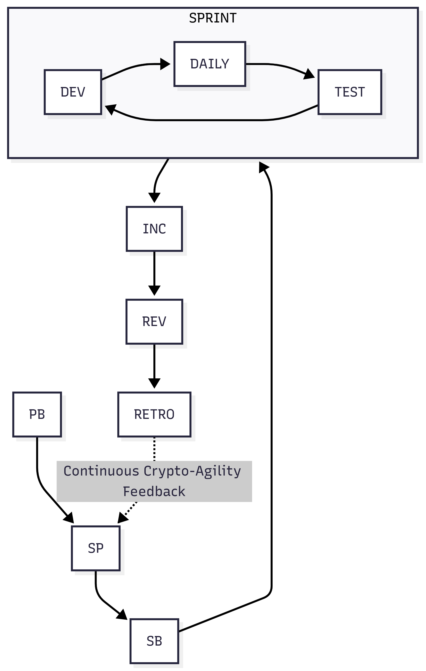
Figure 3 1 Agile Development Life Cycle

3.4 System Modelling
To accurately conceptualise and document the interactions within this distributed microservice architecture, standard Unified Modeling Language (UML) diagrams are proposed. These models provide a structural and behavioral blueprint necessary for the robust implementation of the cryptographic system.
The Use Case Diagram maps the primary interactions between the actors—namely the Clinician, the Clinic Administrator, and the System Auditor—and the core functionalities of the system. Clinicians engage with use cases such as 'Create Patient Record' and 'Retrieve Medical History', which internally trigger the 'Request Encryption Key' and 'Decrypt Payload' use cases handled by the Key Management System. Clinic Administrators engage with 'Tenant Onboarding' and 'Key Rotation Policies', illustrating the administrative oversight required for maintaining cryptographic hygiene.
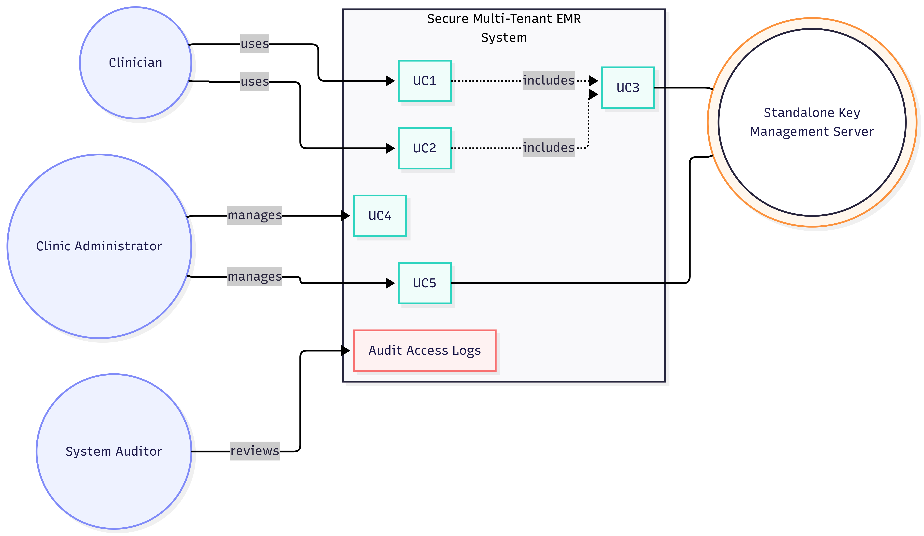
Figure 3 2 Use Case Diagram Of Tenant System
The Activity Diagram details the sequential and parallel execution paths during the creation of a secure medical record. It begins with the data input phase, transitioning to the conditional logic of authenticating the request via JSON Web Tokens. Upon successful authentication, the activity splits into asynchronous parallel branches: the application structuring the data payload while simultaneously waiting for the Key Management Server to return the generated and encrypted cryptographic keys. The diagram highlights the critical security checkpoints, ensuring that the plaintext key is scrubbed from memory immediately following the AES-GCM encryption operation, before the final activity of writing the ciphertext to the isolated PostgreSQL schema.
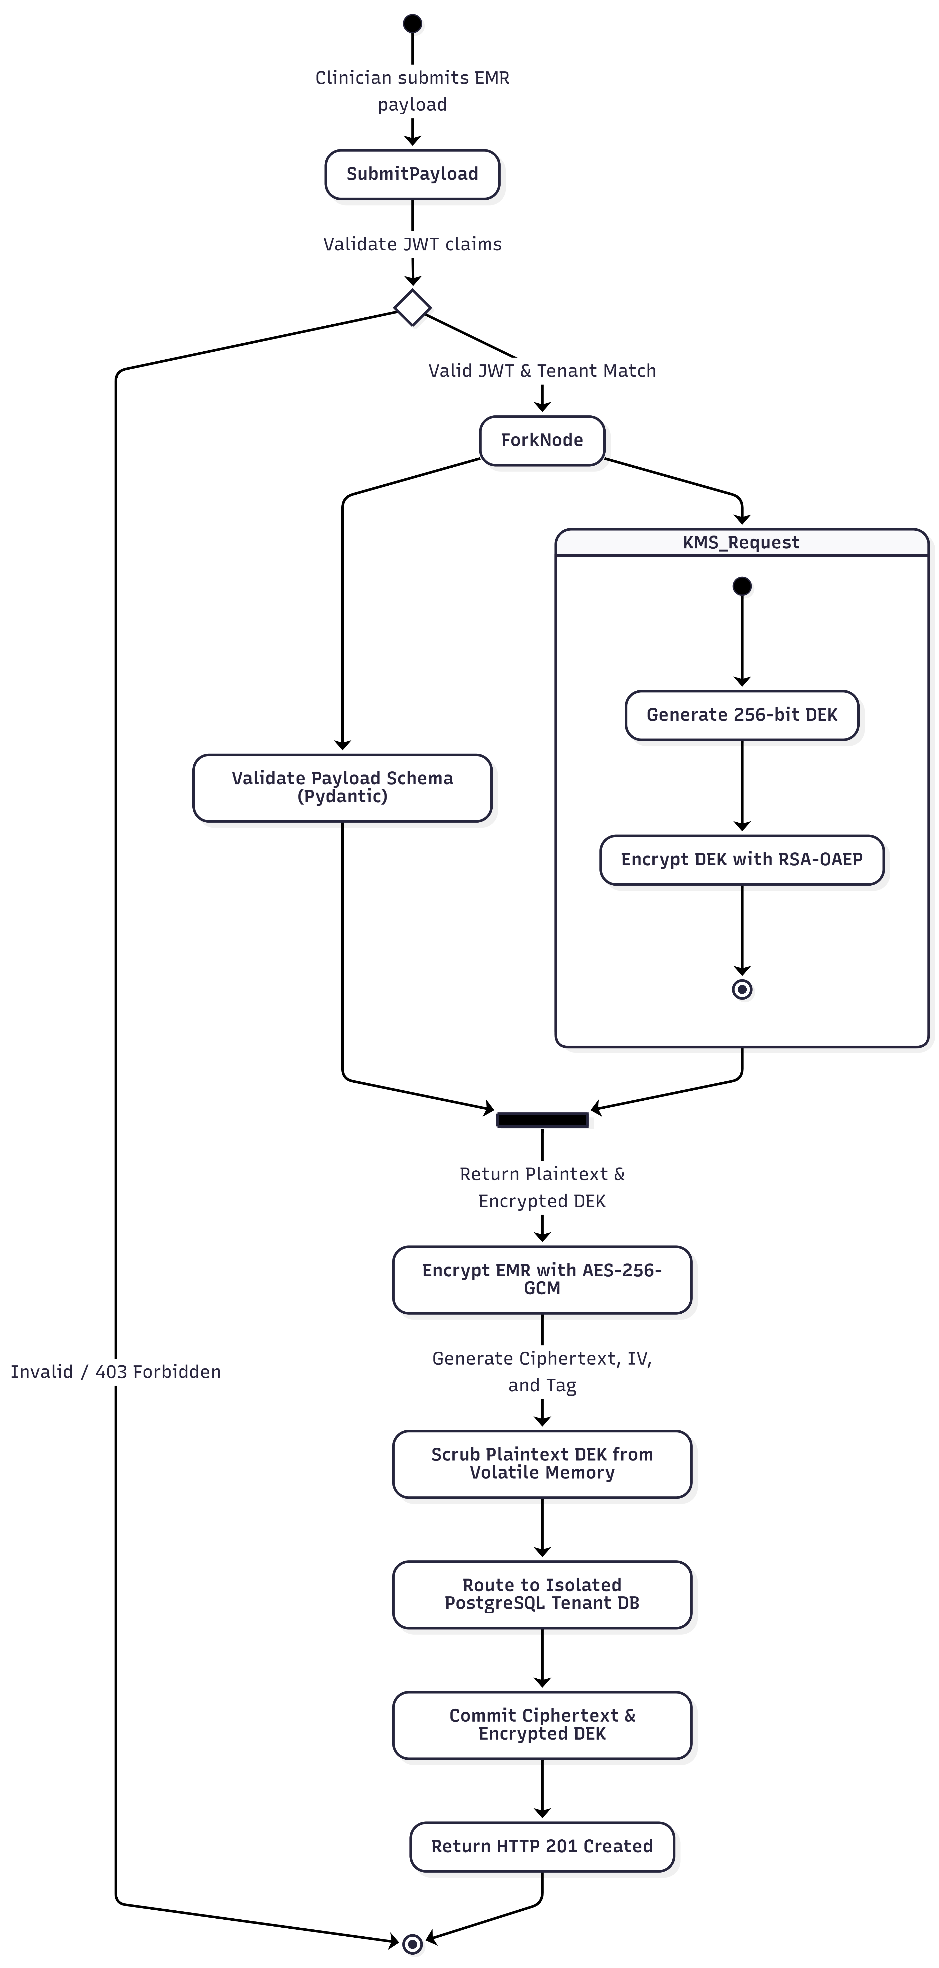
Figure 3 3 Activity Diagram Of Tenant System
The Sequence Diagram provides a granular, chronological visualization of the messages exchanged between the software components. It illustrates the precise order of operations when a read request is initiated. The diagram tracks the initial HTTP GET request from the client to the Core Application API, the subsequent querying of the PostgreSQL database to retrieve the ciphertext and Encrypted Data Encryption Key, the secure internal POST request to the FastAPI server containing the encrypted key, the decryption execution within the Key Management Server utilizing the master Key Encryption Key, and finally, the return of the plaintext key to the application for payload decryption and response formatting.

Figure 3 4 Sequence Diagram Of Tenant System

3.5 Evaluation Plan and Cost-Benefit Analysis
The evaluation methodology is designed to quantitatively assess the two primary objectives of this research: operational performance (latency and throughput) and financial cost-efficiency.
To evaluate operational performance, the custom FastAPI Key Management Server will be subjected to simulated load testing. The testing environment will utilize benchmarking tools to generate high-concurrency requests mimicking a busy regional healthcare network during peak operational hours. The metrics recorded will include the average latency per encryption/decryption request, the 95th and 99th percentile response times, and the maximum requests per second the server can sustain before failure. The performance of the FastAPI server, optimized with uvloop and thread pool execution for the CPU-bound cryptographic operations, will be analysed to ensure it meets the sub-millisecond latency requirements critical for medical applications.
The financial cost-efficiency evaluation will consist of a comparative Total Cost of Ownership analysis. The operational expenditure of the standalone infrastructure—calculated based on the fixed monthly costs of the underlying virtual machines or container orchestration platforms required to host the FastAPI server—will be directly compared against the variable pricing model of AWS Key Management Service. Utilizing the official pricing parameters, where AWS charges a flat fee per customer-managed key and an additional $0.03 per 10,000 API requests, the analysis will project the monthly financial burden across varying transaction volumes. By extrapolating these costs for an expanding multi-tenant environment processing millions of medical records, the evaluation aims to conclusively demonstrate that the custom cryptographic architecture provides equivalent Zero Trust security and HIPAA compliance while entirely eliminating the exponential API billing overhead that currently cripples small-to-medium healthcare providers.

Chapter Four

Implementation and Testing / Results and Discussion

4.1 Implementation
This project implements a Secure Cryptographic Key Management System for Electronic Medical Records with two cooperating services: the Core Medical Application API (Core App) and the Standalone Key Management Server (KMS). The Core App is responsible for provisioning tenants, creating medical records, and retrieving record metadata. Conversely, the KMS is an isolated microservice strictly responsible for generating and decrypting tenant-specific encryption keys and producing Data Encryption Keys.
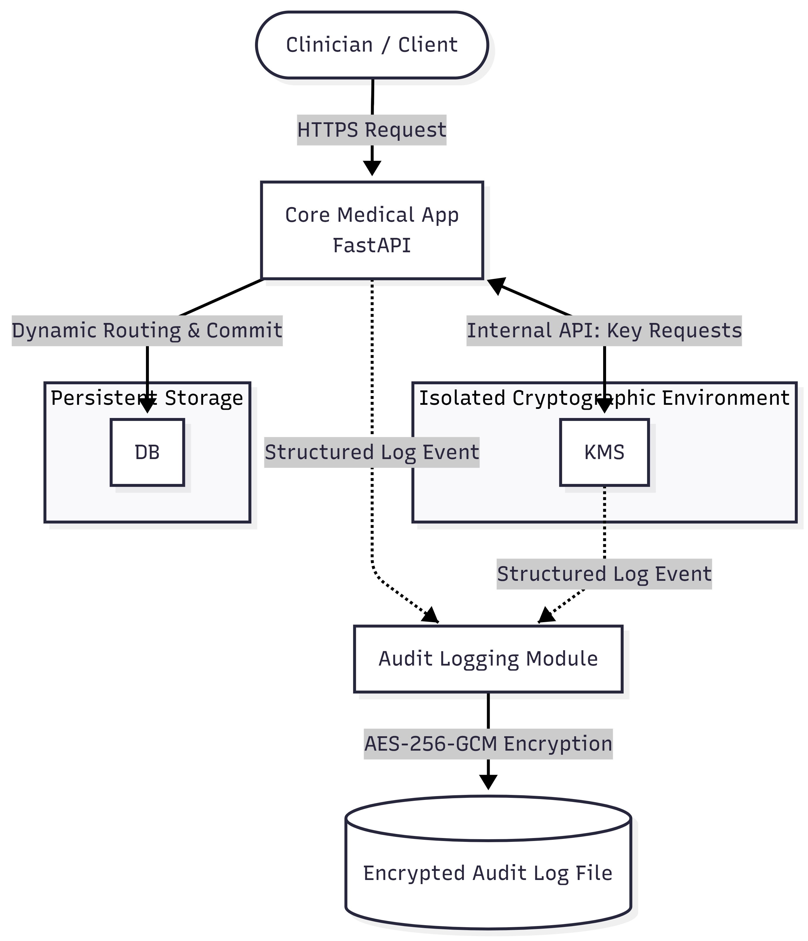
Figure 4. 1: Architecture overview of Core App, KMS, audit logging, and data flow.

4.1.1 Hardware and Software Requirements
To ensure optimal performance and standardisation during the implementation phase, specific foundational technologies were established. The hardware environment required a standard computing system capable of running local server instances and executing concurrent cryptographic operations without severe bottlenecking. The software requirements mandated the use of Python 3.11 or higher to support modern asynchronous typings, the FastAPI framework for high-throughput routing, and PostgreSQL running locally or via Docker to manage the multi-tenant database infrastructure.

4.1.2 Core App (Core Medical Application API)
The Core App operates as a FastAPI service that exposes several critical operational endpoints. Firstly, it handles tenant provisioning, which establishes an isolated record store per tenant to enforce the database-per-tenant architecture. Secondly, it manages record creation by accepting pre-encrypted payload components—specifically the ciphertext, initialisation vector, and authentication tag—and storing them alongside a new, unique record_id. Finally, it facilitates record retrieval by returning the stored encrypted metadata for a specific record when queried.
The security mechanism embedded within the Core App strictly follows the Envelope Encryption paradigm. The primary payload encryption is executed using the highly performant AES-256-GCM algorithm. Each medical record is associated with encrypted key material produced by the KMS. Specifically, the Data Encryption Key is encrypted under the tenant's master key, and in this implementation, only the encrypted Data Encryption Key is carried in the request and response payloads, ensuring that plaintext keys never traverse insecure boundaries.
While the prototype implementation utilised an in-memory dictionary to store records by tenant_id and record_id for rapid demonstration and unit testing, a production deployment fundamentally requires storing encrypted record metadata in the logically separated PostgreSQL database, enforcing strict access control tied to persistent tenant state.
Figure 4.2 Sequence for record creation: authentication → principal checks → record_created audit event.
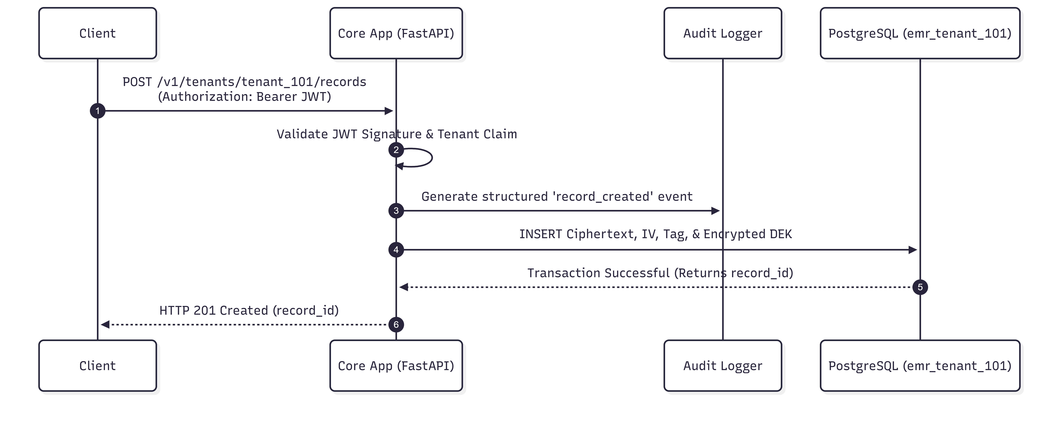
Figure 4.2: Sequence for record creation: authentication → principal checks → record_created audit event.

4.1.3 KMS (Key Management Server)
The Key Management Server is deployed as a distinct, standalone FastAPI service providing endpoints explicitly for cryptographic life-cycle management. Its primary functions include master key rotation for individual tenants, generating Data Encryption Keys, and securely decrypting those Data Encryption Keys upon validated requests.
During this prototype phase, the tenant master key handling dictates that a key pair is generated and securely stored when a tenant_id is first encountered by the system. The master key generation employs the RSA algorithm with a robust 4096-bit key length. The public key is utilised to encrypt the Data Encryption Key via the RSA-OAEP padding scheme, while the highly guarded private key is utilised solely to decrypt the encrypted Data Encryption Key when authorised access is required. The Data Encryption Key itself is a 256-bit AES key, dynamically generated to satisfy the requirements of the envelope encryption workflow.
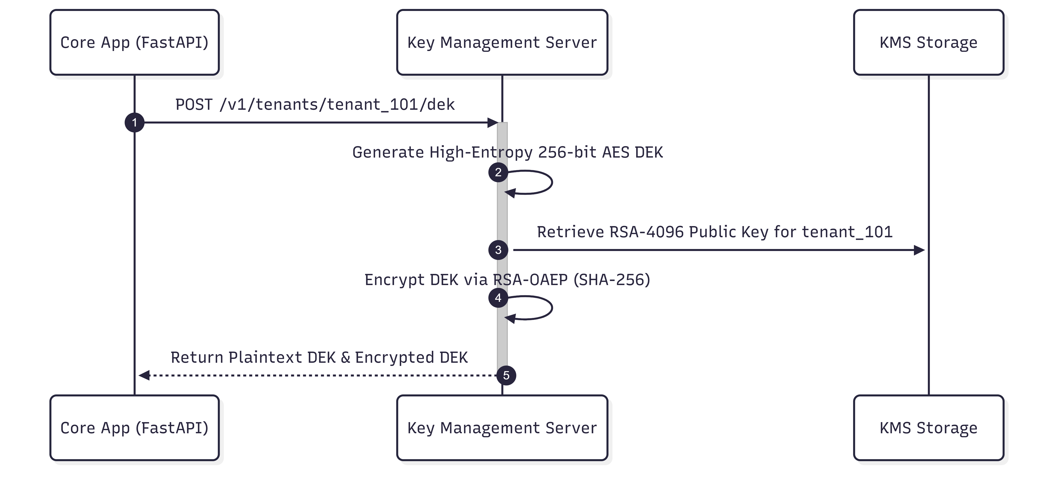
Figure 4.3 : Sequence for DEK generation and encryption under tenant master key (RSA-OAEP).

4.1.4 Audit Logging and Encrypted Audit Records
To support stringent auditability without inadvertently exposing sensitive protected health information within the system logs, the architecture implements encrypted audit logging. Audit records are serialised as JSON objects using a structured formatter. Crucially, each audit message is immediately encrypted using AES-256-GCM prior to storage. This process relies on a freshly and randomly generated nonce for every single log message, alongside an authentication tag produced and implicitly bound by the Galois/Counter Mode to ensure both confidentiality and tamper evidence.
The encrypted audit logs are subsequently written to the disk as length-prefixed binary frames, following the specific structure: [4-byte nonce length][nonce][4-byte ciphertext length][ciphertext]. The primary design goal of this structure is to guarantee that the audit log's confidentiality and integrity are uncompromisingly protected; any tampering with the ciphertext or the nonces will mathematically prevent successful decryption and parsing during a security audit.
Furthermore, a sensitive data redaction filter is applied to the logging pipeline. Known private-key markers or sensitive variables in log messages are automatically redacted to mitigate any risk of accidental key leakage. A controlled plaintext fallback behaviour is also designed into the system, which is only supported when explicitly enabled by an administrator. By default, the system operates on a fail-closed paradigm: if the encrypted audit initialisation fails, the service is engineered to halt rather than silently write plaintext, insecure audit logs to the disk.
The binary frame format illustrated in Figure 4.4 demonstrates the custom serialization protocol engineered for the encrypted audit log subsystem. To guarantee optimal parsing safety and mitigate buffer-overflow or boundary-segmentation vulnerabilities, a prefix-length framing architecture is utilized. Box 1 stores a 4-byte big-endian unsigned 32-bit integer (uint32 BE) representing the precise byte-length of the initialization vector, which is immediately followed by the raw cryptographic nonce itself in Box 2. Following this, Box 3 similarly records a 4-byte big-endian length prefix for the ciphertext payload. Box 4 holds the variable-length ciphertext generated by the AES-256-GCM algorithm, which natively appends the 16-byte GCM authentication tag. Because the length prefixes are strictly declared prior to reading the corresponding binary segments, the logging parser can securely validate frame boundaries, preventing log injection or data truncation attacks
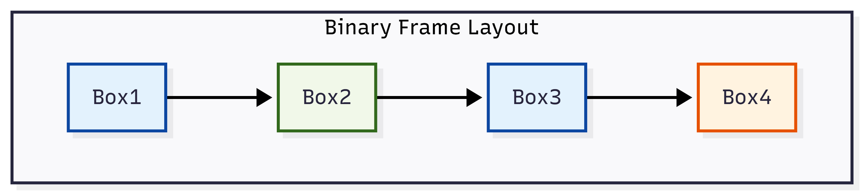
Figure 4.4: Encrypted audit log binary framing: nonce length, nonce, ciphertext length, ciphertext.

4.1.5 Logging Implementation Details
The audit logger is instantiated via a shared, secure logging module across the architecture. Key operational properties include dual handling routing. The logger simultaneously utilizes a console handler, which outputs structured JSON intended solely for development visibility, and an encrypted file handler dedicated to maintaining audit confidentiality in persistent storage. The handler initialization routines are strictly idempotent, a necessary engineering step to avoid the creation of duplicated audit entries during asynchronous service reloads.

Figure 4.5: Encrypted audit logs stored on disk and structured console audit output.

4.2.5 Reliability Testing (Handler Duplication and Cleanup)
To guarantee stability and avoid flaky tests, reliability protocols were enforced. Tests were programmed to ensure that the encrypted audit handler initialization did not inadvertently spawn multiple handlers, which would otherwise produce duplicate log frames and degrade performance. The tests also mandated proper handler closing and cleanup routines post-execution, a critical step that successfully prevented Windows Permission Error exceptions typically caused by lingering open file handles during rapid, automated testing cycles.

4.2 System Testing
The primary aim of the testing phase was to rigorously verify the correctness of the encrypted audit log record production and to ascertain that the integrity protection mechanisms were functioning; specifically, proving that any manual tampering with the log files would actively prevent decryption. Furthermore, the testing phase verified correct application behavior, the emission of expected audit events when endpoints were called, the successful enforcement of JSON Web Token (JWT) validation and tenant isolation checks, and the overall reliability of the test execution across host platforms to mitigate file handle locking issues.

4.2.1 Testing Approach and Methodology
The testing strategy combined multiple layers of validation. Unit and component testing were executed through the direct cryptographic validation of the encrypted log frames to ensure mathematical soundness. Integration-level testing was subsequently conducted utilizing the Fast API Test Client. During integration tests, automated HTTP requests were executed against both the Core App and the KMS instances, while the audit logger was patched to write outputs to a test-specific encrypted log file rather than the production directory.
Environment variable control was paramount during this phase. The LOG_ENCRYPTION_KEY variable was mandated in the test environment to enable the decrypting of audit logs during verification steps. Similarly, the JWT_SHARED_SECRET was injected to ensure that the JWT validation and subsequent OAuth2 bearer token checks could succeed seamlessly during the testing of the core endpoints.

4.2.2 Test Environment
The test environment was built upon a modern Python runtime ecosystem, leveraging dependencies such as the FastAPI framework, the core cryptography library, and the pytest ecosystem. The FastAPI TestClient was utilised for endpoint invocation without requiring fully booted server instances. Temporary, isolated directories were generated dynamically for the creation of encrypted log files, ensuring that subsequent test runs did not suffer from data contamination. Finally, custom AES-GCM decryption logic was embedded directly into the test assertions to automatically validate that the generated audit frames were decryptable and genuinely tamper-evident.

4.2.3 Functional Testing (Endpoints)
Functional testing targeted the primary operational endpoints of both microservices. Within the Core App, the tenant provisioning endpoint was tested to verify that a successful HTTP 201 Created response was returned and that an audit record containing the expected tenant_provisioned message and tenant context was successfully emitted to the encrypted log.
Similarly, the record creation endpoint was evaluated to confirm it yielded a successful status code only when a cryptographically valid JWT was supplied, and the tenant_id claim explicitly matched the requested URL path. The test also verified the presence of the record_created audit event. For the KMS, the Data Encryption Key generation endpoint was tested to ensure it returned a successful response payload containing the RSA-encrypted key, whilst simultaneously verifying that the dek_generated audit record was logged with the correct contextual identifiers.

4.2.4 Security Testing (Encrypted Log Integrity)
Security-oriented tests were designed to physically stress the integrity mechanisms of the system. A deliberate tamper detection test was executed wherein; after encrypting the logs, the testing script intentionally flipped a single byte within the encrypted log file on the disk. The subsequent assertion verified that decryption failed catastrophically, definitively proving that the AES-GCM authentication tag effectively protects the audit records from stealthy modifications.
Additionally, a frame boundary tamper test was conducted. The test script corrupted the length prefix (the nonce length or frame boundary markers) within the binary file. This action successfully broke the parsing and decryption logic, confirming the structural correctness and resilience of the binary framing design against data corruption techniques.

4.3 Results Presentation
This section records the observed results from running the comprehensive test suite against the engineered architecture. The automated end-to-end smoke test successfully demonstrated that the system components communicate, encrypt, and persist data exactly as intended.
Table 4.1: Summary of Tests Executed
S/N | Test Name | Type | Expected Outcome | Actual Outcome
1 | Tenant ProvisioningTenan | Functional | HTTP201 Created; tenant_provisioned audit emitted | Pass
2 | Record Creation | Functional | HTTP 201 Created; record_created audit emitted | Pass
3 | DEK Generation | Functional | HTTP 200 OK; dek_generated audit emitted | Pass
4 | Log Tampering | Security | Decryption fails due to AES-GCM integrity check | Pass
5 | Frame Boundary Tampering | Security | Parsing/decryption fails entirely | Pass
6 | Handler Cleanup | Reliability | No duplicate frames or PermissionErrors detected | Pass
Following the successful execution of the endpoint workflows, the encrypted audit logs were extracted and verified. The structured format of these logs provides high visibility into the system's operations without exposing the underlying plaintext payloads.
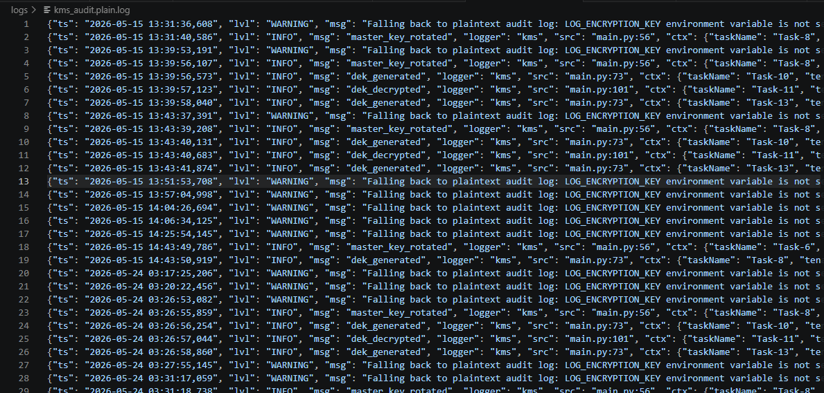
Figure 4.6: Sample decrypted JSON audit record showing structure and contextual metadata.

Table 4.2: Audit Message Coverage Map
S/N | Endpoint Invoked | Expected Audit Message
1 | POST /v1/admin/tenants/{tenant_id}/provision | tenant_provisioned
2 | POST /v1/tenants/{tenant_id}/records | record_created
3 | GET /v1/tenants/{tenant_id}/records/{record_id} | record_accessed
4 | POST /v1/tenants/{tenant_id}/master-keys/rotate | dek_generated
55 | POST /v1/tenants/{tenant_id}/master-keys/decrypt | dek_decrypted
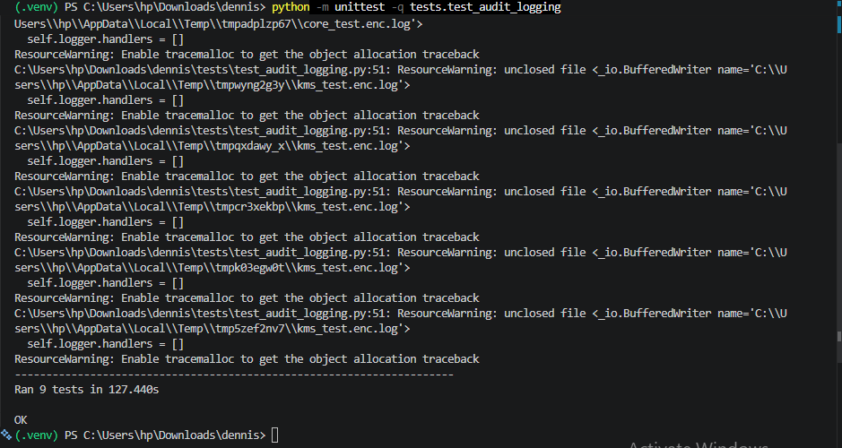
Figure 4.7: Unit/integration test execution results output confirming system stability.

4.4 Discussion
The discussion connects the empirically observed results directly to the foundational objectives of this research project. The system successfully achieved its goals regarding confidentiality, integrity, and comprehensive auditability within a multi-tenant healthcare environment.
Regarding confidentiality, the tests confirmed that the encrypted audit logs successfully utilise the AES-256-GCM algorithm, guaranteeing that highly sensitive audit content and system metadata are not stored in a readable format on the server disk. In terms of integrity, the deliberate tamper tests empirically validated that the AES-GCM authentication mechanism works flawlessly; any unauthorised modification or tampering with the encrypted frames immediately triggers a mathematical failure, preventing decryption and alerting administrators to the compromise.
Furthermore, the system achieved robust auditability. The decrypted audit logs successfully provided structured JSON fields containing critical forensic data, including the timestamp (ts), the severity level (lvl), the explicit action message (msg), the logger designation (logger), the precise source file and line number (src), and vital contextual metadata (ctx) such as the tenant_id and the record_id. This granular level of auditing strictly aligns with the compliance requirements dictated by HIPAA and the NDPA.
While the implemented prototype successfully validates the cryptographic theory and asynchronous performance metrics, certain limitations inherent to the prototype scope must be acknowledged. The use of in-memory data stores for the temporary holding of records and master keys during unit testing reduces the overall realism and persistence of the system. A full production design must expand upon this foundation by integrating the fully persistent PostgreSQL database for tenant state, employing secure hardware key storage (such as a Hardware Security Module or a protected key vault) for the ultimate protection of the RSA master keys, and implementing strict operational access controls and continuous network monitoring.
In conclusion, the implemented system successfully demonstrates that a self-hosted, standalone FastAPI Key Management Server can provide enterprise-grade envelope encryption and encrypted audit logging with strict integrity protection. The architecture successfully verified all expected audit events and cryptographic lifecycles during endpoint usage, proving its viability as a cost-effective, high-performance alternative for local healthcare providers.

Chapter Five

Summary, Conclusion and Recommendation

5.1 Summary
This project presented the design and implementation of a Secure Cryptographic Key Management System for Electronic Medical Records used by local healthcare providers. The system demonstrates secure cryptographic handling, strict separation of concerns, and the confidentiality and integrity of audit records.
The major components of the system include the Core Medical Application API, the Standalone Key Management Server, and the Encrypted Audit Logging Subsystem. The Core Medical Application API handles tenant provisioning alongside record creation and retrieval. It enforces tenant authorisation checks utilising JWT-based authentication and emits structured audit events for key actions such as tenant provisioning, record creation, and record access. The Standalone Key Management Server manages tenant master keys and performs operations related to Data Encryption Keys. It generates these keys and protects them using RSA-OAEP encryption under tenant public keys, while also supporting master key rotation for individual tenants. Finally, the Encrypted Audit Logging Subsystem encrypts audit logs using AES-256-GCM and writes tamper-evident, framed binary records to the disk. It utilizes JSON formatting and contextual metadata to support audit analytics, applies redaction filters to reduce the chance of logging sensitive key material, and operates with controlled fail-closed behaviour for encrypted audit initialisation.
Based on comprehensive testing and validation, several key outcomes were achieved. Encrypted audit records generated by the audit handler proved to be fully decryptable in a controlled test environment using the shared audit encryption key. Integrity protection was successfully validated, demonstrating that any tampering with the ciphertext or frame boundaries causes decryption and parsing to fail entirely. Furthermore, endpoint integration tests confirmed that the expected audit messages and tenant contexts consistently appear in the encrypted logs when the Core Application and Key Management Server endpoints are exercised.

5.2 Conclusion
The project concludes that a highly secure envelope encryption design can be practically implemented using AES-256-GCM for medical record confidentiality and integrity, alongside RSA-OAEP for protecting per-record Data Encryption Keys under tenant-specific master keys. Furthermore, the research demonstrates that encrypted, structured audit logs can be implemented effectively, ensuring that audit trails remain confidential at rest while preserving tamper-evidence through authenticated encryption.
The automated tests conducted during this study provide practical assurance that audit events are emitted correctly, encrypted log formats can be reliably parsed and verified, and data integrity is strictly enforced against unauthorized tampering. While the implemented prototype is demonstrative and utilizes in-memory stores for testing efficiency, it successfully captures the foundational security engineering concepts required for a scalable, production-ready healthcare architecture.

5.3 Recommendations
To improve the system for a live production deployment, several critical engineering and architectural recommendations must be addressed.
Regarding key management enhancements, the system must replace the temporary in-memory RSA private keys with a secure, persistent key storage solution, such as a Hardware Security Module, a managed cloud Key Management Service, or a dedicated protected key vault. Administrators should implement strict key rotation policies with enforced minimum and maximum retention windows. Furthermore, explicit versioning enforcement must be added to ensure decryption operations validate the key version and explicitly reject mismatched versions. The system should also support comprehensive audit and compliance reporting for key usage to track which identities accessed specific keys, alongside the temporal and contextual reasons for that access.
To harden the audit logging mechanisms, fail-closed behaviour must be strictly enforced in production, entirely disabling the plaintext fallback mechanism in security-sensitive environments. Administrators must add log file rotation and retention policies to avoid unbounded storage growth and improve operational management. Additionally, access control hardening is required to ensure that only explicitly approved services or compliance users can read the audit encryption keys and decrypt the logs.
Concerning data persistence and system design, the architecture must transition to persisting tenant state and record metadata in a robust relational database, maintaining the logically separated database-per-tenant architecture or implementing strict row-level security. Encryption at rest must be enabled for all metadata where applicable. The development team should also implement robust error handling and consistent input validation to ensure that any malformed encrypted data is handled securely without leaking stack traces or cryptographic details.
Finally, testing and validation protocols must be expanded. Security tests should be extended to include replay and duplication resistance checks, multi-tenant cross-access negative tests to proactively attempt privilege escalation, and extensive malformed payload tests. Performance testing should be introduced to measure the exact latency for key generation, record creation, and audit logging throughput under heavy concurrent loads. Integration tests must also be expanded to cover end-to-end flows, tracing a request from the Core Application through the Key Management Server operations, into encrypted storage, and concluding with audit verification.

5.4 Areas for Further Research
Future work in this domain should explore the automated verification of cryptographic invariants using formal methods or property-based testing. Additionally, research should focus on improving the scalability of the architecture for massive multi-tenant workloads by integrating distributed caching and advanced asynchronous processing pipelines. There is also a significant need for stronger threat modelling and mathematical security proofs to further validate the audit confidentiality and tenant isolation guarantees provided by the architecture. Finally, conducting usability testing and developing operational runbooks for real-world deployment in local, resource-constrained healthcare provider environments will be essential for driving industry adoption.

REFERENCES
Abhishek. (2026, March 25). Blog: Balancing Encryption Costs and Performance for Multi-Cloud. From TECHVZERO: https://techvzero.com/balancing-encryption-costs-performance-multi-cloud/
Beardsley, M. (2020, May 18). Blog: Multi-tenant data isolation with PostgreSQL Row Level Security. From AWS: https://aws.amazon.com/blogs/database/multi-tenant-data-isolation-with-postgresql-row-level-security/
Benav, I. (2025, September 13). igorbenav: FastAPI Mistakes That Kill Your Performance. From Dev: https://dev.to/igorbenav/fastapi-mistakes-that-kill-your-performance-2b8k
Braincuber Technologies. (2026, March 10). Blog: Self-Hosted LLMs vs API-Based LLMs: Cost & Performance Analysis. From Braincuber Technologies: https://www.braincuber.com/blog/self-hosted-llms-vs-api-based-llms-cost-performance-analysis
Censinet. (2025). Perspectives: HIPAA Encryption Protocols: 2025 Updates. From Censinet: https://censinet.com/perspectives/hipaa-encryption-protocols-2025-updates
Copeland, C. (2024, December 18). Blogs: Multi-Tenant Databases with Postgres. From Midnyte City Logo: https://www.midnytecity.com.au/blogs/multi-tenant-databases-with-postgres-row-level-security
Dalai, D. K. (2025, November 8). @dikhyantkrishnadalai: FastAPI Performance Bottlenecks: Why Middleware and ORMs Kill Throughput (and How to Fix Them). From Medium: http://medium.com/@dikhyantkrishnadalai/fastapi-performance-bottlenecks-why-middleware-and-orms-kill-throughput-and-how-to-fix-them-a79924bfaebb
Dunn, L. C. (n.d.). Blog: Choosing Public vs. Private Cloud for Medical Software. From ModMed: https://www.modmed.com/resources/blog/choosing-public-vs-private-cloud-for-medical-software
Dwivedi, D. (2021, July 23). Blog: AWS KMS Vs Azure Key Vault Vs GCP KMS. From Encryption Consulting: https://www.encryptionconsulting.com/aws-kms-vs-azure-key-vault-vs-gcp-kms/
EC-Council University . (2023, April 7). Blog: The Importance of Data Security in Electronic Health Records. From EC-Council University.
Edwar Andrés Pineda Rincón, L. G.-S. (2021). Design of an Architecture Contributing to the Protection and Privacy of the Data Associated with the Electronic Health Record. Information.
Hamade, J. (2025, September 12). @justhamade: Data Isolation and Sharding Architectures for Multi-Tenant Systems. From Medium: https://medium.com/@justhamade/data-isolation-and-sharding-architectures-for-multi-tenant-systems-20584ae2bc31
Harris, F. (2026). Design and Implementation of a Secure Cloud Platform for Electronic Medical Records. ScienceOpen Preprints, 2-40.
Henry, K. (2025, August 16). Blog: Best Practices for Securing Health Data: Practical Steps for Encryption, Access Control, and Compliance. From Accountable: https://www.accountablehq.com/post/best-practices-for-securing-health-data-practical-steps-for-encryption-access-control-and-compliance
Hilkka Woods, T. G. (2024). Multi-Tenant Architecture Design in Cloud-Native Applications.
Horn, P. (2026, Febuary 4). hsm-vs-kms. From accutivesecurity: https://accutivesecurity.com/hsm-vs-kms/
Jason Way, V. P. (2026, January 8). Blog: Key Management Systems: Cloud-Based vs On-Premises KMS Solutions. From futurex: https://www.futurex.com/blog/key-management-systems-software-vs-hardware
John Riggi, N. A. (2024, October 7). Blog: A Look at 2024’s Health Care Cybersecurity Challenges. From American Hospital Association: https://www.aha.org/news/aha-cyber-intel/2024-10-07-look-2024s-health-care-cybersecurity-challenges
Kevin, H. (2025, August 16). Blog: Best Practices for Securing Health Data: Practical Steps for Encryption, Access Control, and Compliance. From Accountable: https://www.accountablehq.com/post/best-practices-for-securing-health-data-practical-steps-for-encryption-access-control-and-compliance
Kirupa Shankar Komathi Maathavan1, a. S. (2021, September 3). A Secure Encrypted Classified Electronic Healthcare Data for Public Cloud Environment. DOI:10.32604/iasc.2022.022276.
Krystal Chinenye Ugwu-Anyanwu, T. K. (2025, November). Data Proection. From ResearchGate: https://www.researchgate.net/publication/394393744_Assessment_of_Compliance_with_Data_Protection_and_Privacy_Regulations_in_the_Nigeria_Healthcare_Sector
Krystal Chinenye Ugwu-Anyanwu, U. M. (2025, November). Data Protection. From ResearchGate: https://www.researchgate.net/publication/394393744_Assessment_of_Compliance_with_Data_Protection_and_Privacy_Regulations_in_the_Nigeria_Healthcare_Sector
Marco Eichelberg, K. K. (2020, october 29). Cybersecurity in PACS and Medical Imaging: an Overview. doi: 10.1007/s10278-020-00393-3, pp. 1527–1542.
Maryam Ahmadi, N. A. (n.d.). Capabilities and Advantages of Cloud Computing in the Implementation of Electronic Health Record. pp. 24–28.
McGee, M. K. (2024, December 25). From govinfosecurity: https://www.govinfosecurity.com/how-healthcare-cyberattacks-broke-records-in-2024-a-27116
McGlothlin, J. (n.d.). The middle market is embracing AI to drive innovation and efficiency.
Meghna Desai, M. T.-D. (2024). Implementation of Agile in healthcare: methodology for a multisite home hospital accelerator.
Mohammad Ali Saberi, H. M. (2025). From Data Silos to Health Records Without Borders: A Systematic Survey on Patient-Centered Data Interoperability. Information, 16(2), 106.
Mohammad Ali Saberi, H. M. (2025). From Data Silos to Health Records Without Borders: A Systematic Survey on Patient-Centered Data Interoperability. Information, 16(2), 106.
Panos Kampanakis, M. C. (2026, April 3). Blogs: How AWS KMS and AWS Encryption SDK overcome symmetric encryption bounds. From AWS: https://aws.amazon.com/blogs/security/how-aws-kms-and-aws-encryption-sdk-overcome-symmetric-encryption-bounds/
Raphael do Vale, J. C. (2026, January 23). Blog: FastAPI Best Practices. From auth0: https://auth0.com/blog/fastapi-best-practices/
Raphael Scheible, F. T. (2023). Integrating row level security in i2b2: segregation of medical records into data marts without data replication and synchronization. Information.
Richard Hillestad, J. B. (2005, September). Can Electronic Medical Record Systems Transform Health Care? Potential Health Benefits, Savings, And Costs. Vol. 24, No. 5.
Tom. (2024, August 22). TomTalksIt: Optimizing FastAPI for High Performance: A Comprehensive Guide. From Medium.
Ugwu-Anyanwu, K. C. (2025, November). Computer Science . From ResearchGate: https://www.researchgate.net/publication/394393744_Assessment_of_Compliance_with_Data_Protection_and_Privacy_Regulations_in_the_Nigeria_Healthcare_Sector
Vidals, G. (2025, Mar 27). Blog: Zero Trust Security for Healthcare: Why Your HIPAA Compliance Strategy Needs an Upgrade. From Medium: https://hipaavault.medium.com/zero-trust-security-for-healthcare-why-your-hipaa-compliance-strategy-needs-an-upgrade-fba4541fbd00

